**TAGLINE:**

**Explore the immigration interests in-depth with ImmiChat, bridging the global immigrants!**

**CONTENT:**

**Associating you with the right community embracing the immigration interests!**

*ImmiChat* is the one-stop application with multiple features for astonishing experiences. It is the first platform focusing on the interests of immigrants worldwide. It has the profiles of most of the folks, and the feed is a blend of the images and descriptions posted by them.

Register now and connect with the folks sharing the same interests for enhanced motivation with exclusive features!

Follow the categories of your choice and country that is best suited for you, and get all the experiences in the ‘*For You’* feed. With this, you can connect with the immigrants from across the globe sharing the same interests and getting the right reviews necessary for ensuring the right decision.

The array of features ensured by *ImmiChat* does not end here, as it has a lot more to unveil with a blend of the best quality features and smooth working!

Let us have a glance over the top accessible features by *ImmiChat*:

* **Icons:**An easy to use and simple interface with exemplified icons to make the navigations easily understood are embedded in *ImmiChat*.
* **Search:**An observant searching feature with several categories embedded for specification and categorization including TOEFL, USMLE, several country-wise categorizations, and many exams/entrance-wise categorizations too.
* **Notification:**Ringing the bells with notification to get informed about any new updates is offered too with *ImmiChat*.
* **Less Data utilization:**This app ensures lesser data consumptions and can also work swiftly with lower network availability.
* **Spam proof:**This app is secure, and it also goes through the verifications to secure the user profiles from spam and frauds and ensure the right information for them. No messaging feature also saves the app from becoming a generic chatting one instead of a utility app.
* **Classy appearance:***ImmiChat* has an attractive and classy appearance with simple and decent navigations that ensures world-class experiences.
* **Paced working:**It is extra touch-sensitive and works extremely fast for navigations, feed addition, and any other service.
* **Right issue resolvers: One can also resolve their immigration-related queries and get suggestions and solutions from the right immigrants through comments on their posts.**
* **Image sharing: Immigrants can share their experiences supported by to ensure better suggestive feed for the new information seekers. Also, the questions can be added too supported by images for better understanding.**
* **Sharing and caring: *ImmiChat* supports sharing features to ensure helping your friends and colleagues and sharing with them the right feeds with them that might be of interest.**

**The list doesn’t end here as with every step and navigation inside *ImmiChat*, you will reveal several fascinating experiences, and it has all the services embedded that are a necessity for an immigrant.**

Get the world-class suggestions and reviews for best analysis and decision making with *ImmiChat*, a fully-fledged app aiming at the benefits of global immigrants!

**Working towards a new community media application with secure and verified immigrants and right suggestions and reviews.**

As no experience and description are better than a self-experience, so register today and unveil every fascination and astonishing service offered by *ImmiChat* and get the right information from the right app!

**Picture contents:**

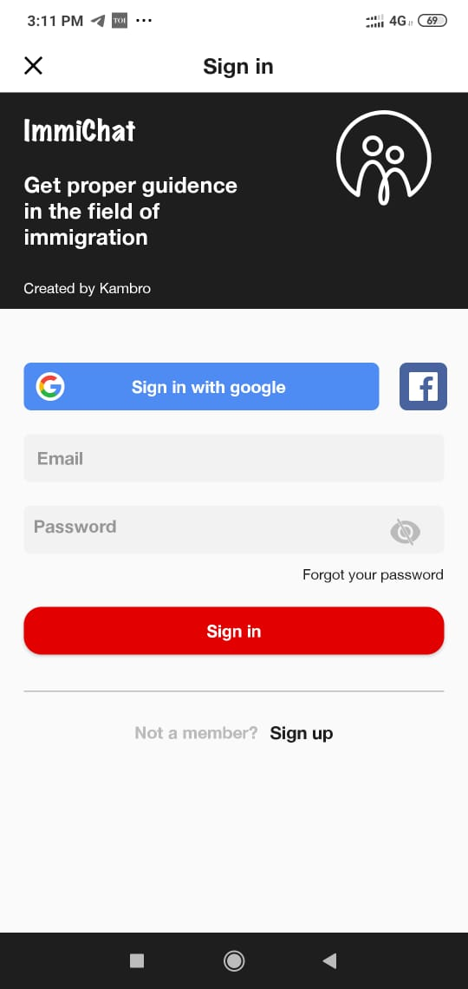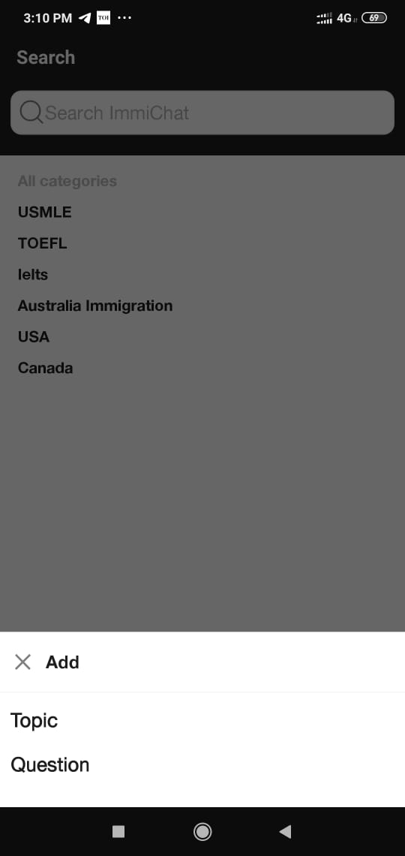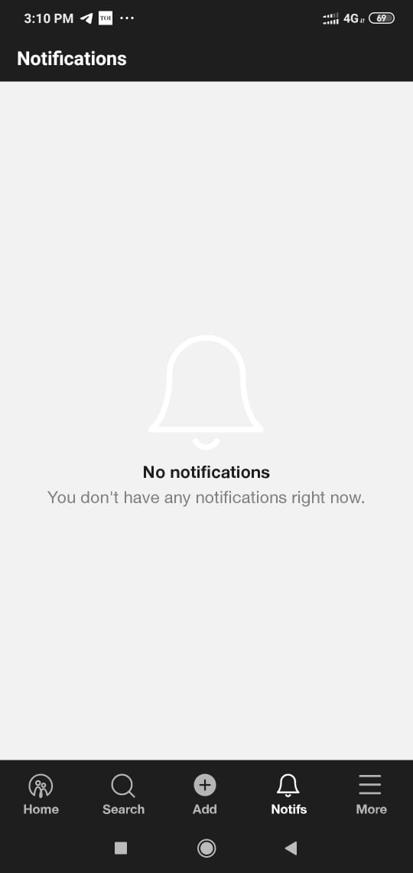

Get bell notified with each update

Add the queries for the right solutions

Google & FB supported registrations

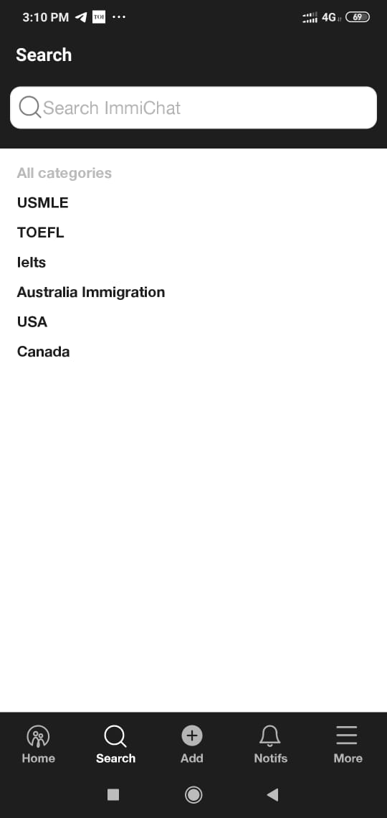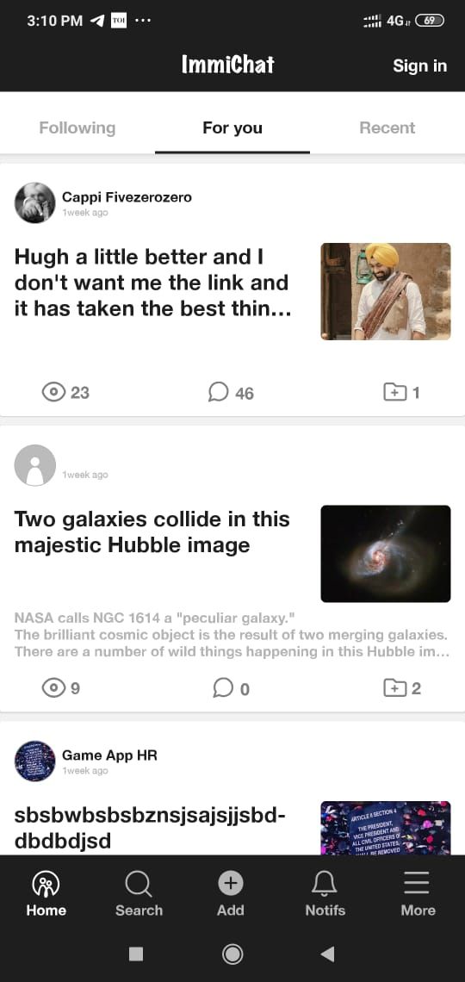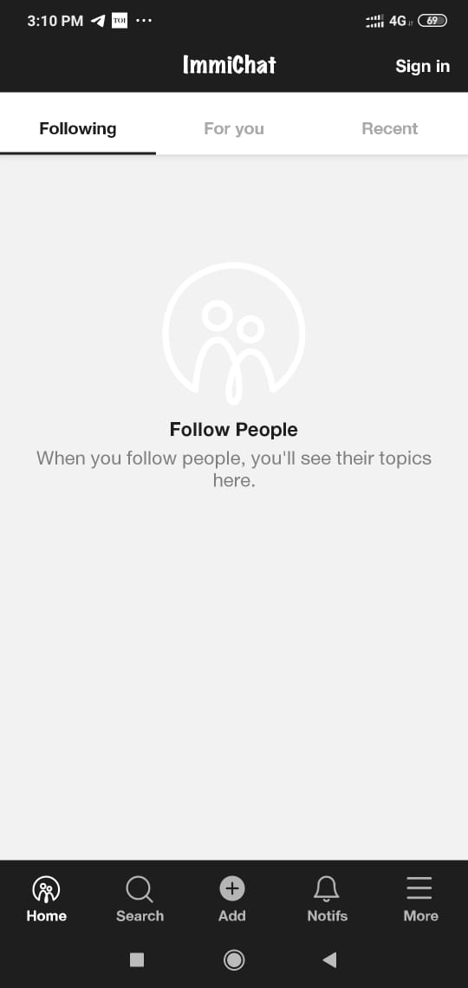

Follow folks with same immigration interests

A feed with all what you need and like

Multiple searches for varying choices

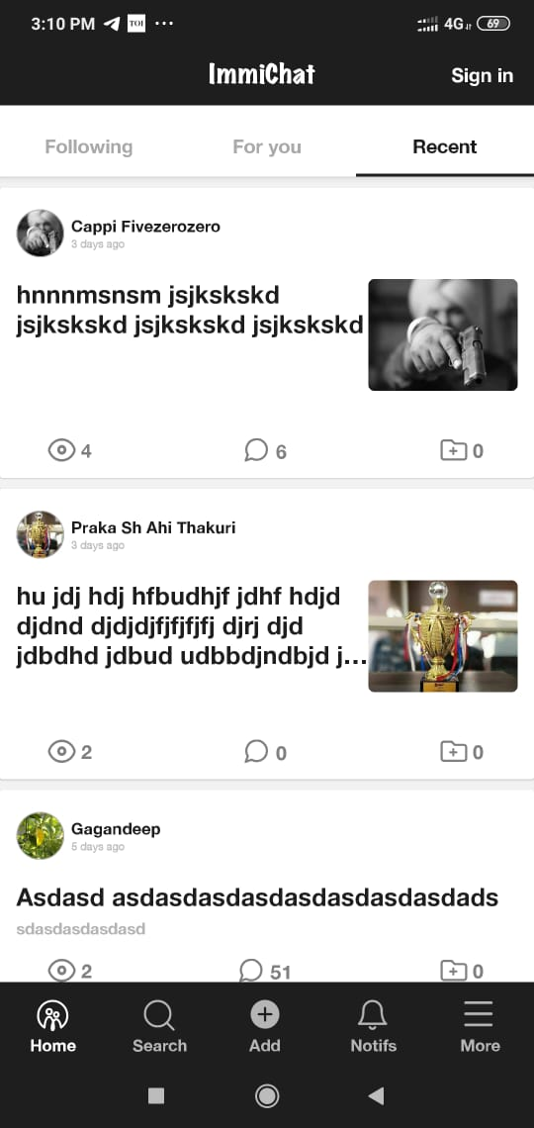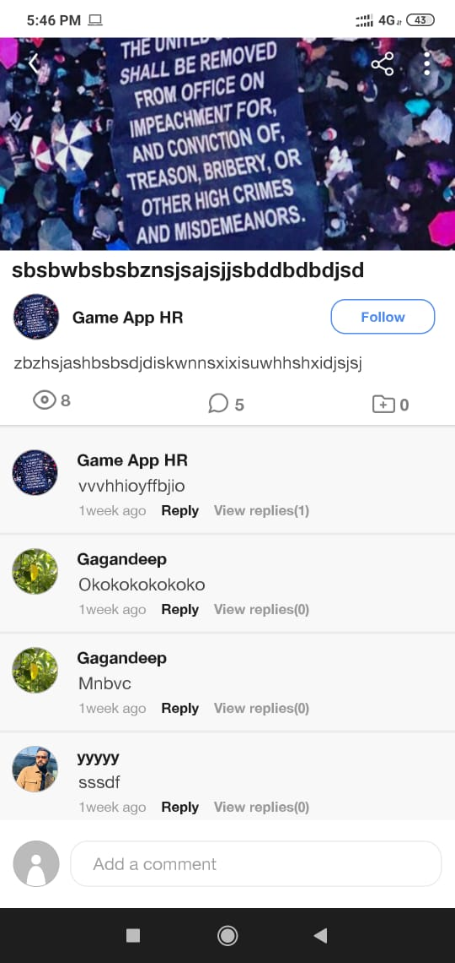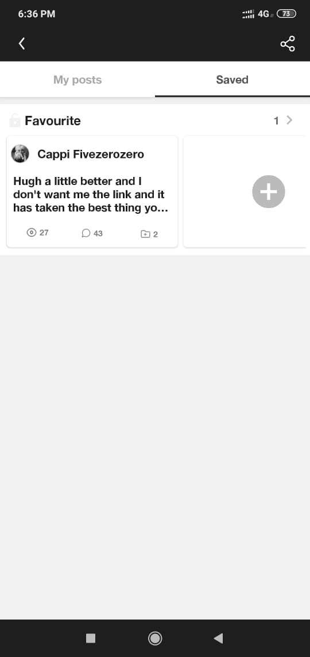

From the more section, get access to the saved folders

Get details of posts and access to comments.

Get access to recent and trendy posts